6.15 (30 points):

A nickel-titanium alloy is used to make components for jet turbine aircraft engines. Cracking is a potentially serious problem in the final part because it can lead to nonrecoverable failure. A test is run at the parts producer to determine the effect of four factors on cracks. The four factors are pouring temperature (A), titanium content (B), heat treatment method (c), and amount of grain refiner used (D). Two replicates of a 2k design are run, and the length of crack (in mm x 10-2) induced in a sample coupon subjected to a standard test is measured. The data are shown in the following table.

Table : 6.15 experiment data

|  |  |  |  |  |  |
| --- | --- | --- | --- | --- | --- |
|  | Pour Temperature | Titanium Content | Heat Treat Method | Grain Refiner | Crack Length |
| 1 | -1 | -1 | -1 | -1 | 7.037 |
| 2 | -1 | -1 | -1 | -1 | 6.376 |
| 3 | 1 | -1 | -1 | -1 | 14.707 |
| 4 | 1 | -1 | -1 | -1 | 15.219 |
| 5 | -1 | 1 | -1 | -1 | 11.635 |
| 6 | -1 | 1 | -1 | -1 | 12.089 |
| 7 | 1 | 1 | -1 | -1 | 17.273 |
| 8 | 1 | 1 | -1 | -1 | 17.815 |
| 9 | -1 | -1 | 1 | -1 | 10.403 |
| 10 | -1 | -1 | 1 | -1 | 10.151 |
| 11 | 1 | -1 | 1 | -1 | 4.368 |
| 12 | 1 | -1 | 1 | -1 | 4.098 |
| 13 | -1 | 1 | 1 | -1 | 9.36 |
| 14 | -1 | 1 | 1 | -1 | 9.253 |
| 15 | 1 | 1 | 1 | -1 | 13.44 |
| 16 | 1 | 1 | 1 | -1 | 12.923 |
| 17 | -1 | -1 | -1 | 1 | 8.561 |
| 18 | -1 | -1 | -1 | 1 | 8.951 |
| 19 | 1 | -1 | -1 | 1 | 16.867 |
| 20 | 1 | -1 | -1 | 1 | 17.052 |
| 21 | -1 | 1 | -1 | 1 | 13.876 |
| 22 | -1 | 1 | -1 | 1 | 13.658 |
| 23 | 1 | 1 | -1 | 1 | 19.824 |
| 24 | 1 | 1 | -1 | 1 | 19.639 |
| 25 | -1 | -1 | 1 | 1 | 11.846 |
| 26 | -1 | -1 | 1 | 1 | 12.337 |
| 27 | 1 | -1 | 1 | 1 | 6.125 |
| 28 | 1 | -1 | 1 | 1 | 5.904 |
| 29 | -1 | 1 | 1 | 1 | 11.19 |
| 30 | -1 | 1 | 1 | 1 | 10.935 |
| 31 | 1 | 1 | 1 | 1 | 15.653 |
| 32 | 1 | 1 | 1 | 1 | 15.053 |

1. Estimate the factor effects. Which factor effects appear to be larger?

The main effects are calculated using the information about the mean crack length at each factor level below.

Table : Pour temperature effect estimates

| **Level** | **Least Sq Mean** | **Std Error** | **Mean** |
| --- | --- | --- | --- |
| -1 | 10.478625 | 0.74341273 | 10.4786 |
| 1 | 13.497500 | 0.74341273 | 13.4975 |

Table : Titanium content effect estimates

| **Level** | **Least Sq Mean** | **Std Error** | **Mean** |
| --- | --- | --- | --- |
| -1 | 10.000125 | 0.74341273 | 10.0001 |
| 1 | 13.976000 | 0.74341273 | 13.9760 |

Table : Heat treat method effect estimates

| **Level** | **Least Sq Mean** | **Std Error** | **Mean** |
| --- | --- | --- | --- |
| -1 | 13.786188 | 0.74341273 | 13.7862 |
| 1 | 10.189938 | 0.74341273 | 10.1899 |

Table : Grain refiner effect estimates

| **Level** | **Least Sq Mean** | **Std Error** | **Mean** |
| --- | --- | --- | --- |
| -1 | 11.009188 | 0.74341273 | 11.0092 |
| 1 | 12.966938 | 0.74341273 | 12.9669 |

Using this information, it is simply a matter of taking the difference of the mean crack length at each factor level.

Table : Effect sizes

|  |  |
| --- | --- |
| **Main effect name** | **Effect size** |
| Pour temperature | 3.019 |
| Titanium content | 3.976 |
| Heat treat method | -3.596 |
| Grain refiner | 1.958 |

The largest effects appear to be titanium content, and heat treat method; causing the crack length to increase and decrease respectively.

1. Conduct an analysis of variance. Do any of the factors affect cracking? Use α = 0.05.

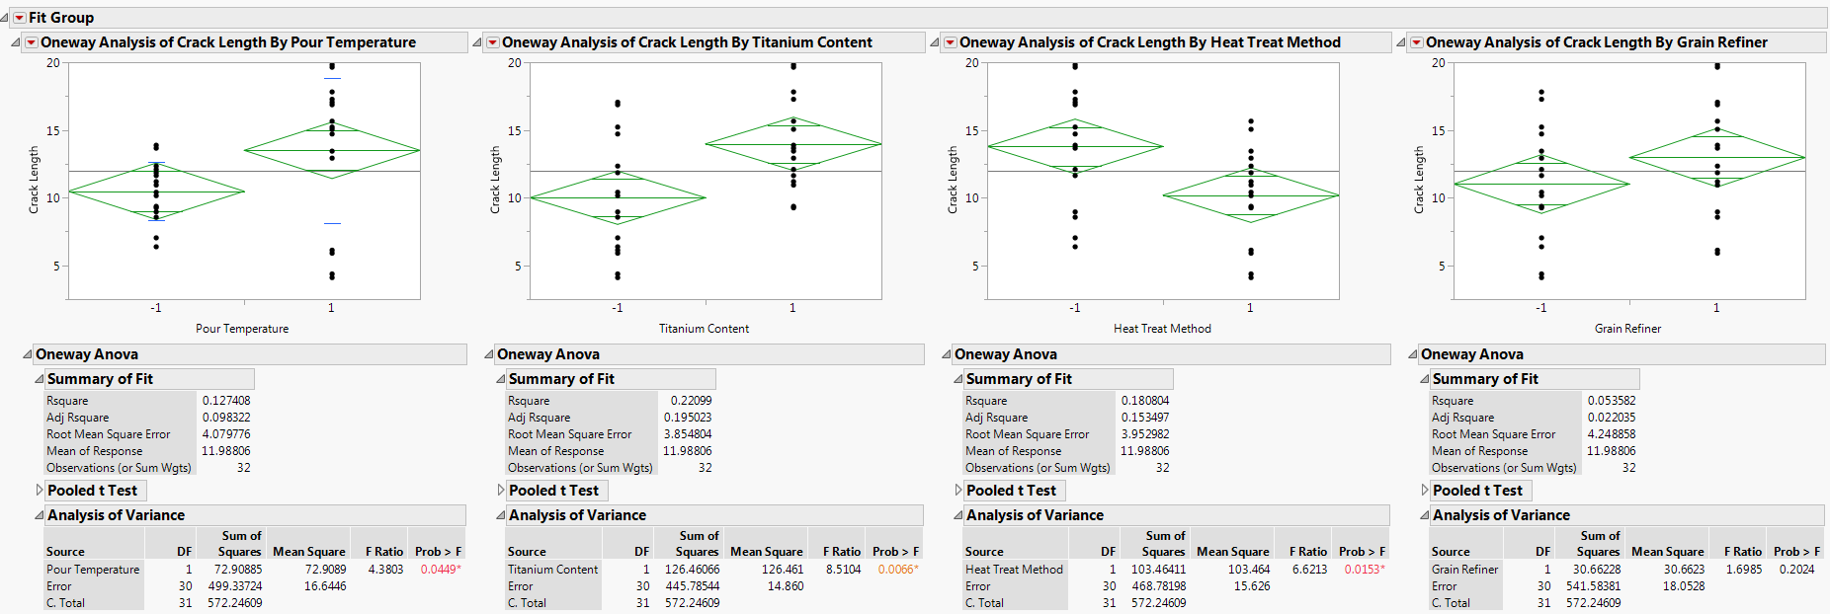

Figure : ANOVA of Crack Length by Pour Temperature



Figure : ANOVA of Crack Length by Titanium Content



Figure : ANOVA of Crack Length by Heat Treat Method



Figure : ANOVA of Crack Length by Grain Refiner

According to these ANOVA tests, Heat treatment method, titanium content, and pour temperature all have statistically significant effects on crack length. They have p = 0.0153, p=0.0066, p=0.049 respectively. The non-siginificant factor, Grain refiner, has a p-value of 0.2024.

1. Write down a regression model that can be used to predict crack length as a function of the significant main effects and interactions you have identified in part B.

Part B does not identify significant interaction effects. So a factorial of degree 2 was run in order to catch any interactions that might be significant. As can be seen in the figure below, there was only one statistically significant interaction: Pour Temperature * Titanium Content.

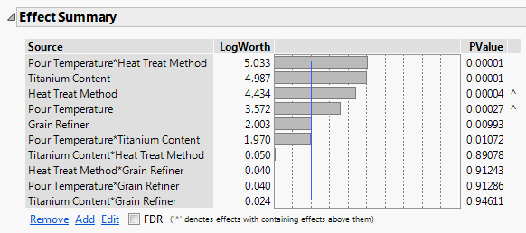

Figure : Effect summary factorial model

However, after removing the interaction effects that were not significant, only the factors that were found significant by the ANOVA remained.

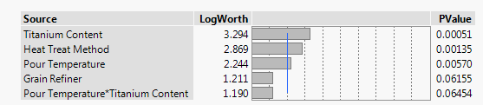

Figure : Follow up effect summary

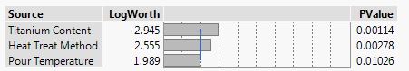

Figure : Final effect summary

Using this final factorial design, the estimates for the regression coefficients were found as shown in the following figure. These estimates were used to construct the regression equation.

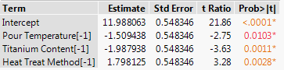

Figure : Regression coefficient estimates

Let Pour Temperature = A, Titanium Content = B, and Heat Treat Method = C.

$$Crack_{length}=11.988-1.509*A-1.988*B+1.798*C$$

Equation : Regression model

1. Analyze the residuals from this experiment.

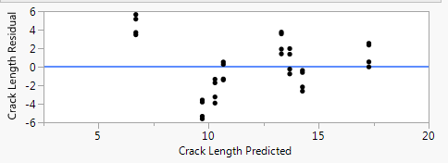

Figure : Residual plot

There do not appear to be any problems with the residuals.

1. Is there an indication that any of the factors affect the variability in cracking?

Subjectively, it looks as though the high level of pour temperature may increase the variability of crack length. See Figure 1.

1. What recommendations would you make regarding process operations? Use interaction and/or main effect plots to assist in drawing conclusions.

It is recommended that the pour temperature be high, the titanium content be high, and the heat treat method be low. As there is no significant effect, it is also recommended that grain refiner not be used in order to save processing cost and complexity.

6.17 (10 points):

An experimenter has run a single replicate of a 2k design. The following effect estimates have been calculated:

A = 76.95

B = -67.52

C = -7.84

D = -18.73

AB = -51.32

AC = 11.69

AD = 9.78

BC = 20.78

BD = 14.74

CD = 1.27

ABC = -2.82

ABD = -6.50

ACD = 10.20

BCD = -7.98

ABCD = -6.25

1. Construct a normal probability plot of these effects.

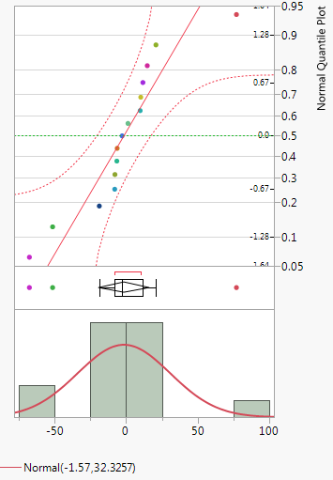 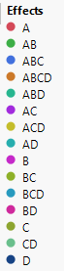

Figure : Normal probability plot

1. Identify a tentative model, based on the plot of the effects in part A.

Effects on the line are not significant. Therefore, we can build our model using the effects:

B, AB, A, D, BD.

Y = Intercept + 76.95A – 67.52B – 18.73D – 51.32(AB) + 14.74(BD)